Nrth Carolina

Esse quam videri (To be, rather than to seem)
Location of North Carolina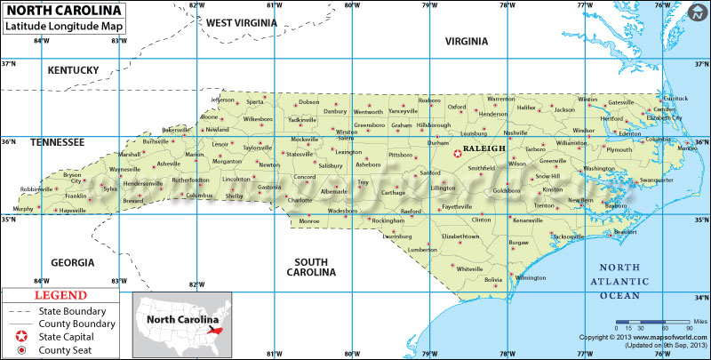
North Carolina is located on the continent of North America and in the country of the USA. It is located between 36.5N-34N latitude and 84W-76W longitude. NC is boarded by the Atlantic Ocean, South Carolina, Georgia, Tennessee, and Virginia.

Regions of North Carolina
Mountain | 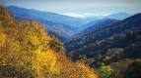 | This is the western part of NC and is the smallest region. Mountain ranges include the Blue Ridge Mountains, the Smokey Mountains, and Stone Mountain. The climate is cooler and vegetation is more sparse. In the mountains, people enjoy skiing, hiking, camping, and going white water rafting.
Piedmont | 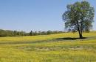 | The piedmont is the middle region of the state. Piedmont means “foot of the mountain.” The elevation ranges from 1500 ft to 300 ft. In this region, people like to go on picnics, ride bikes, boat on lakes, and visit famous places like The Nascar Hall of fame or the Mint Museum.
Coastal Plains | 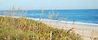 | The land is low and flat. The soil is moist and rich and is one of the state’s best farmland. It has low-lying areas called wetlands where water covers the land. In this region, people enjoy surf fishing, kite surfing, visiting lighthouses, and visiting famous sites like the Write Brothers Museum.

Historical Narrative from NC
North Carolina’s song is called “The Old North State” and was written by William Gaston. It was adopted as the official song of the state in 1927 by the General Assembly.
Here is an excerpt of the song:
Carolina! Carolina! Heaven's blessings attend her!
While we live we will cherish, protect and defend her;
Tho' the scorner may sneer at and witlings defame her,
Still our hearts swell with gladness whenever we name her.
Hurrah! Hurrah! The Old North State forever!
Hurrah! Hurrah! The good Old North State!
Tho' she envies not others, their merited glory,
Say whose name stands the foremost, in Liberty's story,
Tho' too true to herself e'er to crouch to oppression,
Who can yield to just rule a more loyal submission?
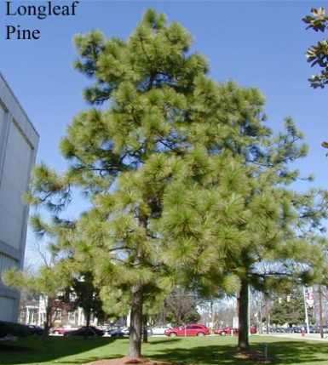
Hurrah! Hurrah! The Old North State forever!
Hurrah! Hurrah! The good Old North State!
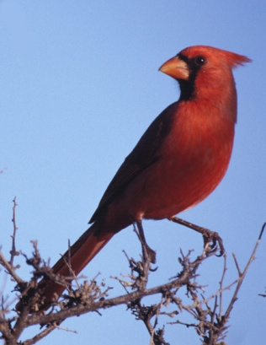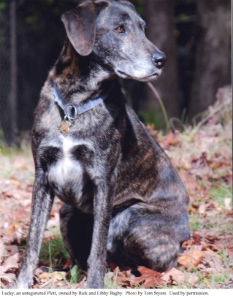
Cardinal Plott Hound Longleaf Pine
Food from North Carolina
There are many foods native of North Carolina. Did you know that Cheerwine, Hardee’s, and Krispy Kreme are all companies based in North Carolina? Mt. Olive pickles, Texas Pete, and Pepsi also are from this state. They are also famous for their BBQ sauce!
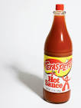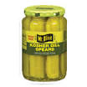
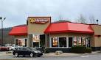
Eastern North Carolina BBQ Sauce

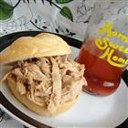

Ingredients:
1 cup white vinegar  1 cup cider vinegar  1 tablespoon brown sugar  1 tablespoon cayenne pepper | 1 tablespoon hot pepper sauce (e.g.  Tabasco™), or to taste  1 teaspoon salt  1 teaspoon ground black pepper
Directions:
1. | Combine the white vinegar, cider vinegar, brown sugar, cayenne pepper, hot pepper sauce, salt and pepper in a jar or bottle with a tight-fitting lid. Refrigerate for 1 to 2 days before using so that the flavors will blend. Shake occasionally, and store for up to 2 months in the refrigerator.
Traditions
North Carolina is rich in traditions. From crafts such as quilting and basketry to storytelling and Jack Tales, there is much to learn and enjoy. Traditions have been passed down through the generations and it is important that we preserve them for generations to come.

In North Carolina some of the traditions include:
- McAdenville Christmas
- storytellers in the mountains,
- quilting in the mountains
- pottery, art,
- ex. Duke vs Carolina

Physical & Manmade Characteristics of NC

Physical Characteristics
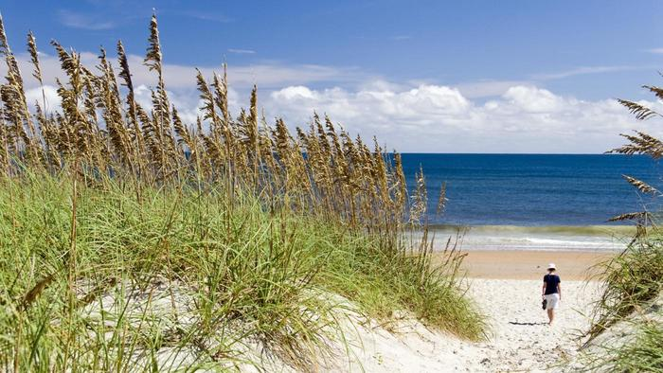
The Blue Ridge Mountains are in the western portion of North Carolina and are a part of the Appalachian Mountains. This area boasts the highest mountain elevation east of the Mississippi River. The name of this mountain is Mount Mitchell, and it sports an elevation of 6,684 feet.
The Piedmont section of North Carolina is full of rolling foothills leading up to the mountainous region of the state. There are some flatter valleys in this area, but some of the hills have an altitude of 300 feet to 1500 feet. The Piedmont is not at the very bottom of the mountains, but it can be somewhat flat in places. The area was given the French name "piedmont" because it is at the foot of the mountain, despite being at a higher elevation.
Along the coast of North Carolina, there are many beaches, sand dunes and cliffs. Many rocks can be seen sticking out of the water on the way to the barrier islands.
The Blue Ridge Mountains are in the western portion of North Carolina and are a part of the Appalachian Mountains. This area boasts the highest mountain elevation east of the Mississippi River. The name of this mountain is Mount Mitchell, and it sports an elevation of 6,684 feet.
The Piedmont section of North Carolina is full of rolling foothills leading up to the mountainous region of the state. There are some flatter valleys in this area, but some of the hills have an altitude of 300 feet to 1500 feet. The Piedmont is not at the very bottom of the mountains, but it can be somewhat flat in places. The area was given the French name "piedmont" because it is at the foot of the mountain, despite being at a higher elevation.
Along the coast of North Carolina, there are many beaches, sand dunes and cliffs. Many rocks can be seen sticking out of the water on the way to the barrier islands.
In the west are the Appalachian Mountains. It has the highest peak east of the Mississippi River. The center of the state has rolling hills with many rivers and lakes. In the eastern section you will see very flat land by the coast of the Atlantic Ocean.
Along the coast of North Carolina, there are many beaches, sand dunes and cliffs. Many rocks can be seen sticking out of the water on the way to the barrier islands.
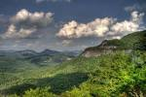
Manmade Characteristics
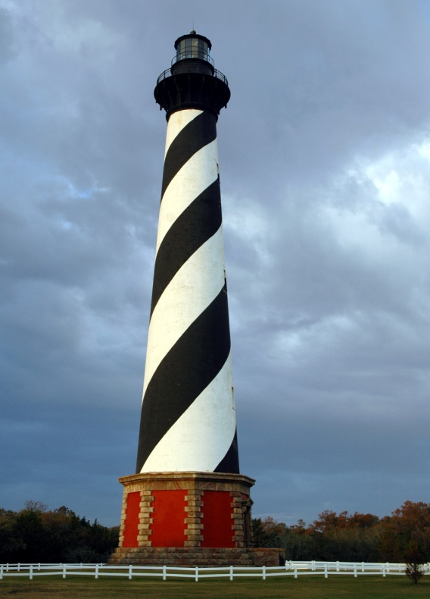
One famous manmade landmark in North Carolina is the Cape Hatteras Lighthouse. It stands 208 feet tall and was built in 1870. It helps ship captains navigate the rough waters off the coast of the Atlantic Ocean. It is a famous tourist attraction for those visiting the Outer Banks of NC.
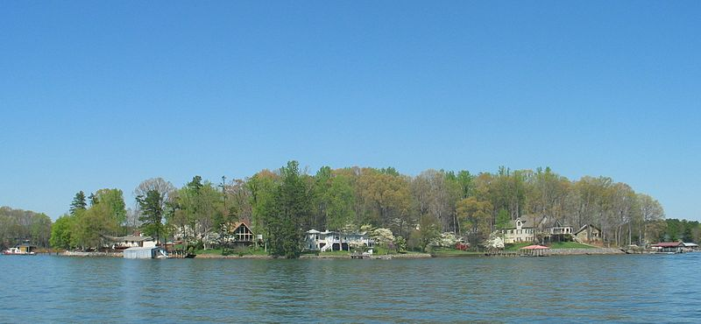
Lake Norman was built in 1963 by Duke Energy and is a popular recreation destination north of Charlotte.
Government of North Carolina

Governor (4 year term): Pat McCrory
He lowered taxes for citizens.

Senator (6 year term): Richard Burr
He served 5 terms in the House of Rep.

Senator (6 year term): Thom Tillis
Said workers shouldn’t have to be forced to wash hands after using the bathroom in restaurants.

House of Representatives: (Serve 2 year terms)
Renee Ellmers David Rouzer
Walter Jones Richard Hudson
David Price Robert Pittenger
Virginia Fox Mark Meadows
Mark Walker Patrick McHenry
Alma Adams George Holding

