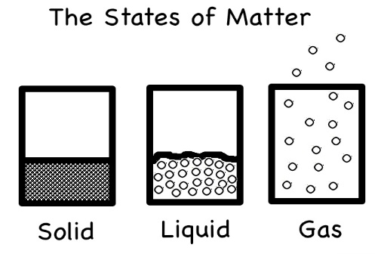
Unit Overview: States of Matter
Unit Goals:
Students will…
3.P.2 Understand the structure and properties of matter before and after they undergo a change.
3.P.2.1 Recognize that air is a substance that surrounds us, takes up space and has mass.
3.P.2.2 Compare solids, liquids, and gases based on their basic properties.
3.P.2.3 Summarize changes that occur to the observable properties of materials when different degrees of heat are applied to them, such as melting ice or ice cream, boiling water or an egg, or freezing water.
Key Vocabulary
-state or form -heat -freeze
-matter -mass -melt
-solid -heat -condensation
-liquid -particles -evaporation
-gas -boil -mixture
-solution -physical change

Textbook Pages to Reference: F12-F21
Essential Questions to think about:
1. Can you create a visual to explain what a gas is, if you are unable to see it?
2. How can you represent the different states of matter (solid, liquid, gas)?
3. What are the effects of heating/cooling on matter?
4. Heat is to evaporation as less heat is to _______ (condensation).

Experiments you can do at home: http://www.stevespanglerscience.com/lab/experiments/category/states-of-matter

